SOMERSET HOUSE’S SPRING ONLINE PROGRAMME
MARCH/APRIL 2021
FREE

- Somerset House’s online cultural programme continues with a new season of activity, with highlights exploring climate change and our relationship with nature
- London’s leading festival of experimental games Now Play This returns to present a new four-day virtual programme with interactive games and play, workshops, and conversations exploring the climate crisis, including Repurpose, a micro-adventure game that sends instructions to participants’ phones, encouraging people to get outside and explore their natural surroundings and Hosni Auji’s Airplane Mode simulator, which simulates the relatable delights and annoyances of airline travel without the carbon footprint
- Somerset House’s Young Producers collective inspire the public to imagine hopeful futures in a climate altered world in a new collaborative project with futures design studio and Somerset House Studios resident Superflux
- TRANSMISSIONS returns for a third season featuring monthly premieres of new commissions and curated works from artists, writers and thinkers including the influential Martha Rosler, Julietta Singh, Jamie Crewe, Ron Athey, Caspar Heinemann and more

As Somerset House’s central London site remains closed to the public, the online cultural programme continues this Spring with an engaging season of interactive activities, new commissions, in-conversation events and creative digital resources, providing inspiration and entertainment to everyone, to be enjoyed from the comfort of home.
Echoing Somerset House’s year-round commitment to sustainability, this season’s programme will include different ways of engaging creatively with climate change, from independent games which allow users to take responsibility for the fate of the planet in interactive simulations, to talks exploring ideas around sustainable living.
Much of the programme has continued to be created in collaboration with artists, residents and collectives who form part of Somerset House’s vibrant community, as well as long-standing partners.

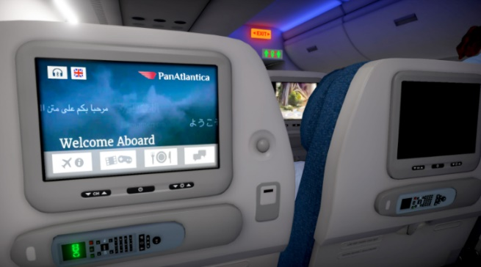
NOW PLAY THIS
25 – 28 March 2021
Free
www.nowplaythis.net

London’s leading festival of experimental games Now Play This returns with a new four-day virtual programme packed with interactive games, workshops, and conversations for people of all ages to enjoy from home.

This year’s edition, presented as part of London Games Festival, explores the climate crisis through games and play, inviting audiences to creatively interrogate the ecological issues faced worldwide today.

Players can enjoy a vast range of both individual and collaborative gameplay, created by an innovative community of makers, designers and artists, with new games becoming available each day of the festival. From taking responsibility for the fate of the planet in interactive simulations, to creating beautiful ecosystems or witnessing environmental destruction in imagined futures, Now Play This 2021 offers a unique gaming experience, forming an exciting and timely online series, open to all ages and abilities.

Festival highlights include:
- Audiences are invited to ‘take flight’ to the festival with a live launch event and discussion within games designer Hosni Auji’s Airplane Mode simulator, offering light-hearted escapism in a time where travel is restricted, simulating the delights and annoyances of the airline travel experience without the carbon footprint of the real thing
- Repurpose, a micro-adventure that sends instructions to participants’ phones, encouraging people to get outside and explore the natural surroundings beyond their home, specially created for Now Play This
- Interactive narrative game Villains and Heroes challenges players to uncover the identity of key players in climate change denial and disinformation campaigns, based on the real-life costume party hosted by multi-billionaire Robert Mercer shortly after the election of Trump in 2016
- Live role-play simulation of UN climate change negotiations in World Climate Simulation, where players can see the impact of their environmental decisions with live analysis from a digital modelling tool
- New interactive design game Among Ripples offers players the chance to experiment with building and maintaining their own lake ecosystem
- Fans of Age of Empires II can convene in the new online chatroom, The Garden of Earthly Delight, a playful new work which allows users to transform into different species from the animal kingdom
- Now Play This join London-based games studio Space Ape to discuss how they achieved their goal of becoming a carbon negative company and to share their thoughts on how we too can be more sustainable

Full festival schedule available via: https://nowplaythis.net/2021-festival/

Now Play This 2021 is supported by Games London and Goethe-Institut

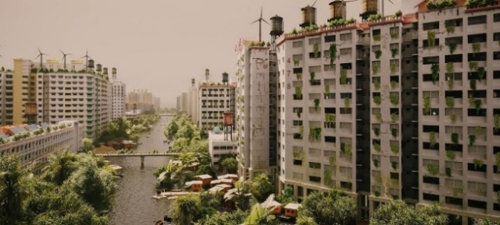
YOUNG PRODUCERS X SUPERFLUX: HOPE IN THE HEAT
Launching Mid-April
Somerset House’s Young Producers present Hope in the Heat, a new series of projects exploring and imagining hopeful visions of a climate altered future, in collaboration with futures design studio and Somerset House Studios resident Superflux.
Hope in the Heat will see the Young Producers create and share their own artistic interpretations of future worlds and ideas by examining and reflecting upon the environmental choices and decisions which impact society today.
Taking form as a series of interactive works, visual displays and a zine, the Young Producers’ creative responses will explore themes of animism, colonial herbology, food crop production, as well as speculative visions of our relationship with future life forms and the shape of our cities. These responses will be available to access via a dedicated online site, which will also feature essays and interviews from the Young Producers, climate scientists and other practitioners.
Hope in the Heat is supported by the Emerging Futures Fund, The National Lottery Community Fund
The Young Producers collective launched in October 2020 as part of Somerset House’s Engagement and Skills programme and offers development and support to young creatives aged 18-30 who are underrepresented in the cultural sector.

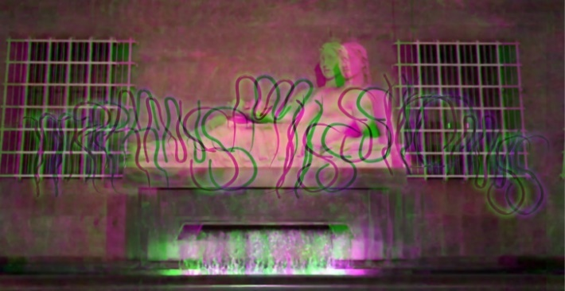
TRANSMISSIONS 3
March - October 2021
Wednesdays 21.00 GMT / Fridays 10.00 GMT
Free
Watch via transmissions.tv

Anne Duffau, Hana Noorali and Tai Shani return with Season 3 of TRANSMISSIONS, an online platform commissioning artists, writers and thinkers to share their work online.
Across its past two seasons, TRANSMISSIONS has provided a community platform to pay and support artists through the continued pandemic landscape, when many have had exhibitions, opportunities and subsequent fees postponed or cancelled. The platform continues to provide a vital space for artists to share their work to a global audience throughout this year, with commissions presented within a DIY TV show format.
With the first episode programmed by Anne, Tai and Hana, the subsequent five episodes will be hosted by invited artists. Each artist included in TRANSMISSIONS will be paid a fee in return for their contribution.
Season 3 launches with a showcase of new commissions and curated works from artists, writers and poets including the influential Martha Rosler, Julietta Singh, Jamie Crewe, Ron Athey, Caspar Heinemann, Ayesha Tan Jones, Peter Spanjer, JJ Chan, Ioanna Gerakidi, Valie Export and Will Harris.
TRANSMISSIONS Season 3 will run as six-monthly episodes screening every Wednesday at 21.00 GMT and repeated on Fridays at 10.00 GMT via transmissions.tv. Each episode will be screened twice only and will not be archived to view again at a later date.
TRANSMISSIONS is produced by Lori E.Allen and Mika Lapid, associate producer.
TRANSMISSIONS Season 3 is supported by Somerset House Studios, Baltic Centre for Contemporary Art, Chisenhale Gallery, Netwerk Aalst, Wysing Arts Centre, South London Gallery and Forma Arts and Media
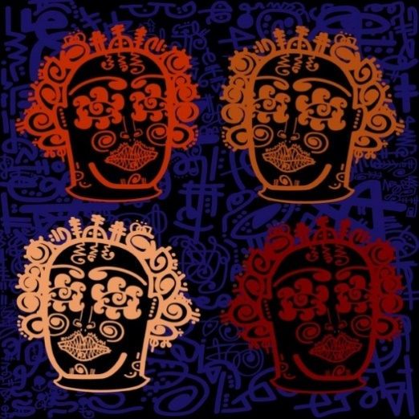
YOUNG PRODUCERS x COMUZI: DECENTRALISE
Launching 16 March 2021
Available to access for free via: somersethouse.org.uk/engagement-and-skills/young-producers/comuzi

Somerset House’s Young Producers collective presents its inaugural project, DECENTRALISE, a new interactive digital platform exploring the cultural history of Black British art at Somerset House, in collaboration with innovative design studio and Somerset House Studios resident COMUZI and project partners Pinterest, with support from Art Fund. ​​
Launching 16 March 2021, DECENTRALISE allows users to engage virtually with 16 key objects from, and inspired by, Somerset House’s exhibition past, the themes of which span Afro-Nowism, Afrofuturism, Political and Disobedient art, through design, interaction and play. ​
Delving into Somerset House’s exhibition archive, from the celebrated Get Up, Stand Up Now (2019) and Return of the Rude Boy (2014) to 2026: Utopian Voices Here & Now (2016), the Young Producers have created illustrated objects inspired by some of today’s most pioneering contemporary Black artists and creators including GAIKA, Richard Rawlins, Althea McNish and David Hammons.

By using these objects as materials, users are encouraged to create and build their own artistic creations within the digital resource, as well as explore how the themes of each work relate to the personal and collective experiences of what it means to be Black and British. ​

RELATED EVENT:

Young Producers in conversation with COMUZI
16 March 2021, 13.00, Streamed event online, Free

To mark the launch of Decentralise, the Young Producers join COMUZI in conversation for a streamed Q&A, giving viewers the chance to meet the Young Producers virtually, as well as hear the inspiration and collaborative journey behind creating the platform throughout lockdown. The event will also demonstrate on how users can create their own works using the site.

The Somerset House Young Producers programme is supported by Art Fund, with additional support for this programme from Pinterest

NOTES TO EDITORS:

ABOUT SOMERSET HOUSE
London’s working arts centre
Somerset House is London’s working arts centre and home to the UK’s largest creative community. Built on historic foundations, we are situated in the very heart of the capital.
Dedicated to backing progress, championing openness, nurturing creativity and empowering ideas, our cultural programme is ambitious in scope. We insist on relevance, but aren’t afraid of irreverence, and are as keen on entertainment as enrichment. We embrace the biggest issues of our times and are committed to oxygenating new work by emerging artists. Where else can you spend an hour ice-skating while listening to a specially commissioned sound piece by a cutting-edge artist?
It is this creative tension – the way we harness our heritage, put the too-often overlooked on our central stage and use our neo-classical backdrop to showcase ground-breaking contemporary culture – that inspires our programme. Old and new, history and disruption, art and entertainment, high-tech and homemade, combined with the fact that we are home to a constantly shape-shifting working creative community: this is our point of difference. It is what we are proud of. And it is what makes the experience of visiting or working in Somerset House inspiring and energizing, urgent and exciting. www.somersethouse.org.uk

